

**Green University of Bangladesh**

**Department of Computer Science and Engineering (CSE)**

**Faculty of Sciences and Engineering**

**Semester: (Spring, Year: 2023), B.Sc. in CSE (Day)**

**LAB REPORT NO: 04**

**Course Title: Engineering Drawing**

**Course Code: CSE-208 Section: DC**

**Lab Experiment Name: Implementation of 3D drawing.**

**Student Details**

|  |  |  |
| --- | --- | --- |
| **Name** | | **ID** |
|  | Md. Sohanur Rahman | 213902106 |

**Lab Date : 25.05.2023**

**Submission Date : 27.05.2023**

**Course Teacher’s Name : Rusmita Halim Chaity**

**[For Teachers use only: Don’t Write Anything inside this box]**

|  |
| --- |
| **Lab Report Status**  **Marks: ………………………………… Signature: .....................**  **Comments: .............................................. Date: ..............................** |

**LAB REPORT TEMPLATE**

**1. TITLE OF THE LAB EXPERIMENT**

Implementation of 3D drawing.

**2. OBJECTIVES/AIM**

* To gain the basic knowledge of 3D drawing tools and techniques.
* To implement the skills to develop basic 3D drawings.
* To gain Knowledge about autoCad and it’s 3D tools. Example: Press/Pull, Exclude etc.
* To implement of All the given 3D task in Lab Report.

**3. PROCEDURE / ANALYSIS / DESIGN**

**Problem Analysis:** 3D modeling and drawing is the process of creating and editing technical drawings, as well as annotating designs.

**3.1. Setting Drawing Limits:** For setting drawing limits Type LIMITS and press enter. Command line will prompt “Specify lower left corner or [ON/OFF] <00-000,00-000>:” simply press enter to accept the default values of the lower left corner which is 0,0.

**3.2. Drawing and Modify tools:**

Use the modeling tools shown in the 3D Modeling workspace to create your model. There are many powerful 3D modeling commands for us to explore in AutoCAD and here are some of the most common ones:

* **Presspull** : Presspull allows you to select a closed drawing object like a wall outline and give it height by moving our mouse to the desired location.
* **Extrude** : Extrude works similarly to Presspull except that, instead of moving your mouse, you enter a numerical value.
* **Sweep:**  Sweep allows you to use a drawing shape or profile we have and extend it along a specified path to create a solid shape. We’ll be using this command in our tutorial below to create a freeform shape.
* **Union:** Union combines multiple selected solids, surfaces, or regions into one.
* **Subtract:** Subtract allows you to create a solid by removing one from another.

**4. IMPLEMENTATION**

**Detailed steps to drawing of Lab Exercise:**

-----Note: drawing details is given column to column-----

* Drawing1: First select polygon and draw three sides polygon. Then press pull the polygon with its height.
* Drawing2: Simply select cone and draw the con with height and radius.
* Drawing3: Simply select cylinder and draw the cylinder with height and radius.
* Drawing4: Simply select pyramid and draw the pyramid with height and width and length.
* Drawing5: Simply select box and draw the box with height and width and length.
* Drawing6: Simply select sphere and draw the sphere with height radius.
* Drawing7: First select polygon and draw five sides polygon. Then press pull the polygon with its height.
* Drawing8: Simply select pyramid and draw the pyramid with height and width and length. Then mirror the pyramid.
* Drawing9: First select polygon and draw six sides polygon. Then press pull the polygon with its height.

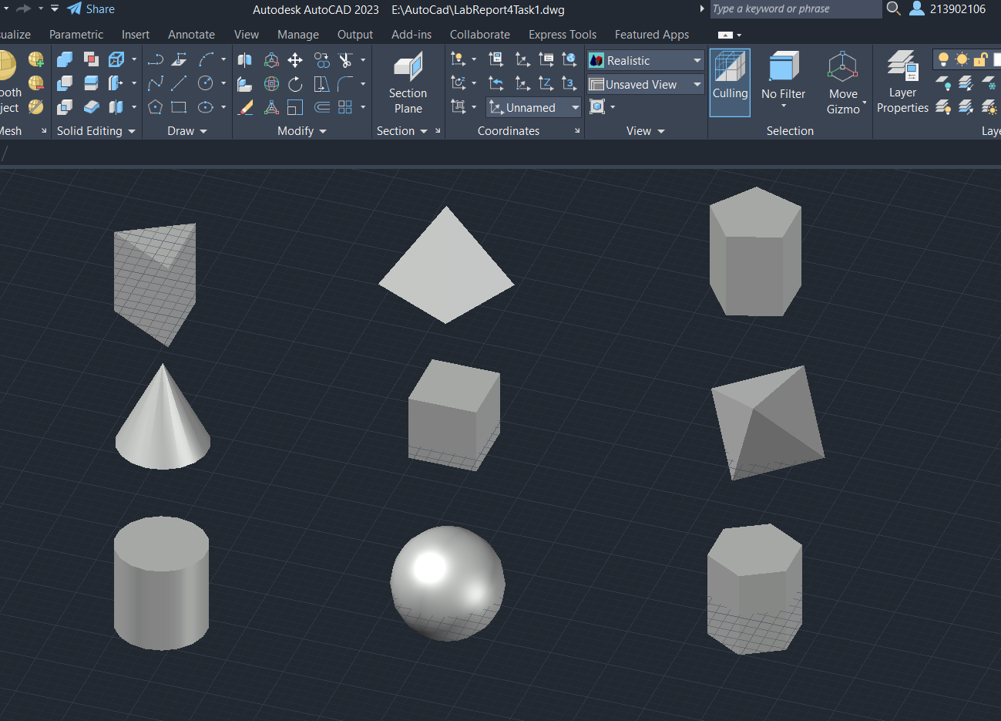

Fig.4.1: 3D Basic Implementation.

**5. TEST RESULT / OUTPUT**

The result or output of the given task is given below. Where we can see that when I am goes to measure the diameter, length and height successfully. Before measurement I am draw the given tasks. It can measure successfully but the height is not measure with correct order. It is the drawbacks of this experiment.

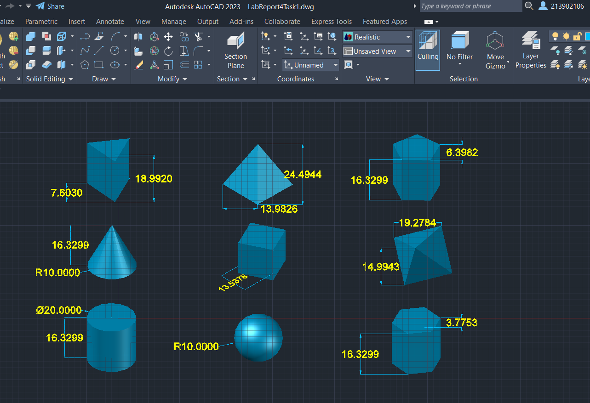

Figure: 4.2: Final basic 3D Drawing

**6. ANALYSIS AND DISCUSSION**

Based on the focused objective(s) to understand about the basic knowledge of 3D modeling and implement those to design a real life object. And the lab exercise made us more confident towards the fulfilled of the objectives. And in this experiment I am learn about some basic drawing tools and how to implement the given task using those tools. When I goes to solved the given tasks I face some problem. But I am overcome this problem by analyzing in a long time. And finally my Lab Experiment-4 is done. This is all about of this lab experiment 4.